**Project Design Phase-I**

**Proposed Solution Template**

|  |  |
| --- | --- |
| Date | 19 May 2023 |
| Team ID | NM2023TMID19358 |
| Project Name | Project - Gas Pipeline Monitoring System For Hospitals |

**Proposed Solution Template:**

Project team shall fill the following information in proposed solution template.

|  |  |  |
| --- | --- | --- |
| **S.No.** | **Parameter** | **Description** |
|  | Problem Statement (Problem to be solved) | Simplify & speed up operations essential for the safe transportation of your commodities. We provide innovative and efficient solutions that perfectly fit to your purposes. 24/7 Customer Service. Real-Time Observability. High Industry Know-how. High Availability. |
|  | Idea / Solution description | This system integrator focuses on providing centralized **gas pipeline monitoring systems for hospitals**. The service they provide makes it possible for |
|  | Novelty / Uniqueness | High-quality and customized medical air compressor solutions that meet medical standards. Discover our range of reliable medical air compressors with the lowest life cycle cost. |
|  | Social Impact / Customer Satisfaction | his paper develops and discusses a classification of conditions such as flow regime and **gas** composition. Also discussed are junction categories which, for .. |
|  | Business Model (Revenue Model) | The global **pipeline monitoring system** market size was valued at USD 14.12 billion in 2021 and is expected to expand at a compound annual growth rate (CAGR) . |
|  | Scalability of the Solution | The basic idea of this paper is to design a complete **system** to **monitor** the medical **gases** in the **hospital**, displaying the output pressures on a desktop computer ... |

**Project Design Phase-I**

**Solution Architecture**

|  |  |
| --- | --- |
| Date | 19 May 2023 |
| Team ID | NM2023TMID19358 |
| Project Name | Project - - Gas Pipeline Monitoring System For Hospitals |

**Solution Architecture:**

Solution architecture is a complex process – with many sub-processes – that bridges the gap between business problems and technology solutions. Its goals are to:

* Find the best tech solution to solve existing business problems.
* Describe the structure, characteristics, behavior, and other aspects of the software to project stakeholders.
* Define features, development phases, and solution requirements.
* Provide specifications according to which the solution is defined, managed, and delivered.

**Example - Solution Architecture Diagram:**

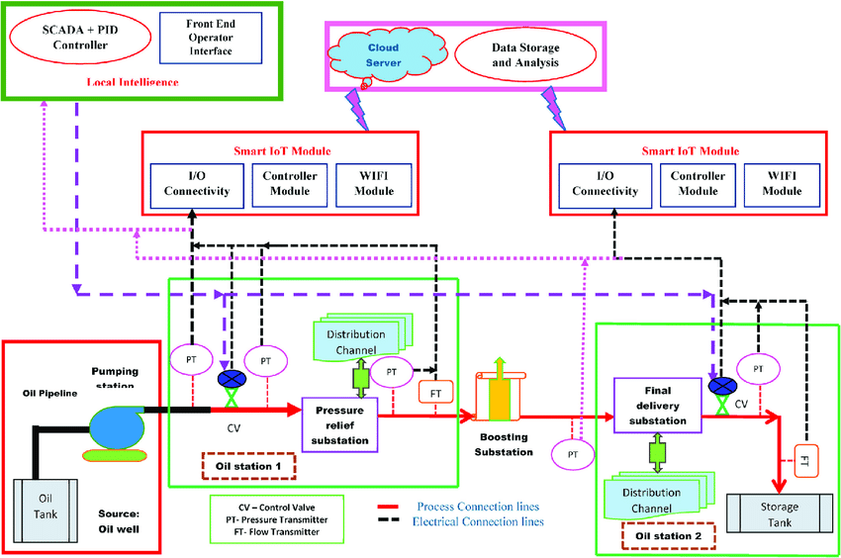

*Figure 1: Architecture and data flow of the voice patient diary sample application*

**Reference:** [**https://aws.amazon.com/blogs/industries/voice-applications-in-clinical-research-powered-by-ai-on-aws-part-1-architecture-and-design-considerations/**](https://aws.amazon.com/blogs/industries/voice-applications-in-clinical-research-powered-by-ai-on-aws-part-1-architecture-and-design-considerations/)